23CSE111

OBJECT ORIENTED PROGRAMMING

LAB MANUAL


Department of Computer Science and Engineering Amrita School of computing
Amrita Vishwa Vidyapeetham, Amaravati Campus

Verified by: NAME: M. GAURAV
ROLLNO: AV.SC.U4CSE24212

S.No. | Experiment Name | Page No. | Remarks | Signature
1 | Installation Process of JDK | 3-6
2 | Simple Java Program for printing basic details of student | 6-10
3 | Simple java programs | 10-21

WEEK-1

- How to download and install java software in your computer.
1.Steps for downloading.
Step 1: Java is developed by oracle. so, open your web browser and search for java oracle.
Step 2: Then go to the website https://www.oracle.com/in/java/ .
Step 3: And navigate to the java downloads. Then some earlier versions are available like
- JDK 23
- JDK 21
- GraalVM for JDK 23
- GraalVM for JDK 21
Step 3: JDK 21 is the latest Long-Term Support (LTS) release of the Java SE Platform. So, we use this version.
Step 4: According to your device operating system choose the product/file description.
Step 5: Then the version will be automatically downloaded.
2.Steps for installation.
Step 1: Go to the folder where it was downloaded.
Step 2: Then open and accept all terms and conditions.
Step 3: And install it.

3.Setting environmental variables.
Step 1: Open file explorer, then right click on This PC next select on properties then it will take you to the settings app then click on advanced system settings and then click on Environment Variables.
Step 2: Click New under System Variables:
    - Set Variable name as: java_home
    - Variable value: The folder address where JDK is installed (like C:\Program Files\Java\jdk-21\bin)
Step 3: Find Path under System Variables, click Edit, and add the path of the jdk-21(D:\UNI+\EDU\JAVA)

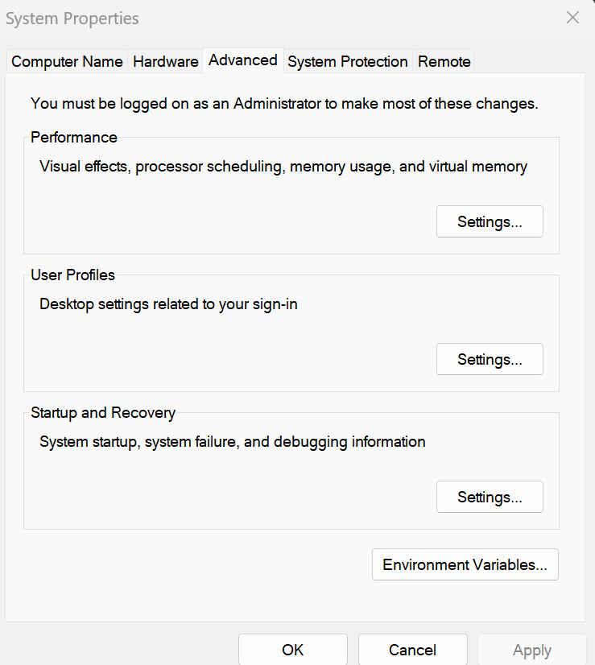

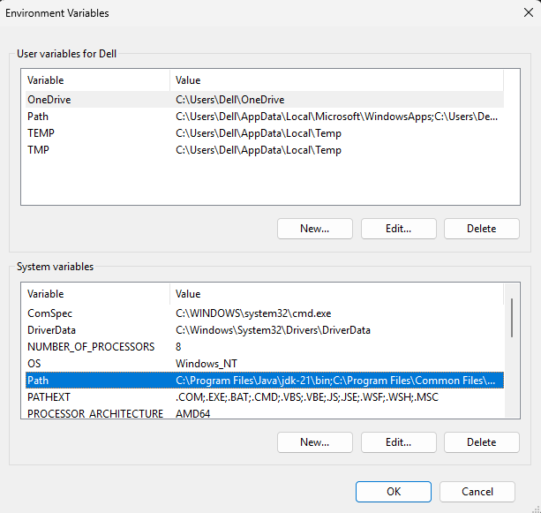

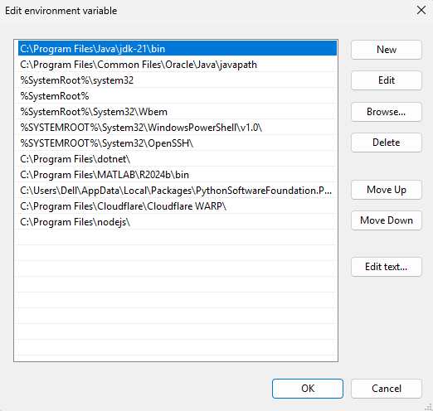
4.Checking for jdk(java development kit) version.
Step 1: Open command prompt.
Step 2: Enter javac --version for version of jdk installed.
Step 3: Enter java –version for all details like when downloaded and path of environment variables
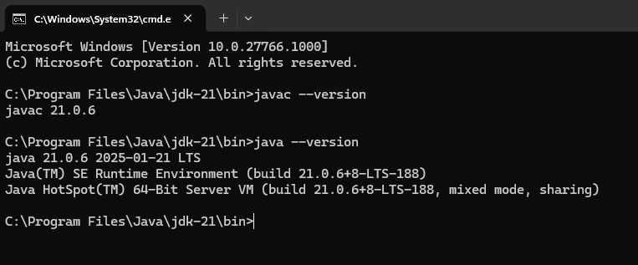
a ) write a simple java program to print your name, roll no,sec etc.

Program :

class Demo
{
public static void main(String[] args)

{
System.out.println("NAME= M. GAURAV");
System.out.println("ROLL NO= AV.SC.U4CSE24212");
System.out.println("SEC= C");
System.out.println("BRANCH= CSE");
}
}

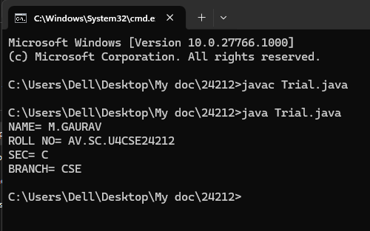
Errors:

S.NO | Error Name | Error Rectification
1 | Syntax/ Compilation Error | Trial.java:6: error: ';' expected  System.out.println("NAME= M.GAURAV")  ^  1 error

WEEK -2 (LAB)
SIMPLE JAVA programs
- WRITE A JAVA PROGRAM TO FIND AREA OF RECTANGLE
Program:
import java.util.*;
class area
{
public static void main(String args[])
{
int area;
Scanner sc = new Scanner(System.in);
System.out.println("Enter Length:");
int l = sc.nextInt();
System.out.println("Enter Breadth:");
int b = sc.nextInt();
area = l*b;
System.out.println("Area of Rectangle :"+area);
}
}

Output:
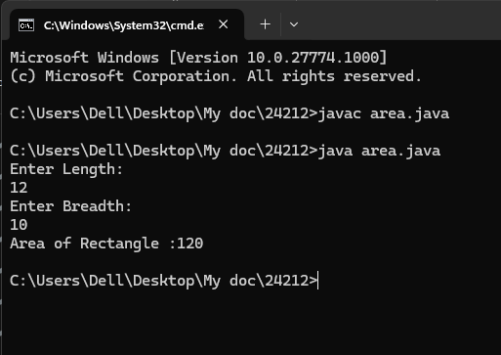
Error:
1 | Syntax error | area.java:7: error: ';' expected  Scanner sc = new Scanner(System.in)  ^  1 error

- WRITE A JAVA PROGRAM TO CALCULATE SIMPLE INTREST:

import java.util.*;
class Simpleinterest{
public static void main(String[] args)
{
System.out.println(" taking input");
Scanner sc = new Scanner(System.in);
System.out.println("enter INTa number:");
float p = sc.nextFloat();
System.out.println("enter a number:");
float t = sc.nextFloat();
System.out.println("enter a num:");
float r = sc.nextFloat();
float s = (p*t*r)/100;
System.out.println("simple intrest is"+s);
}
}
Output:
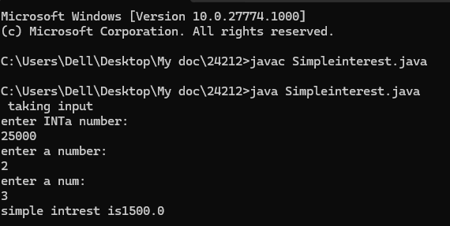

Error:
S.No | Error type | Reason for error
1 | Runtime error | error: file not found: Simpleinterest.java  Usage: javac <options> <source files>  use --help for a list of possible options

- WRITE A JAVA PROGRAM TO FIND FIBNOACCI SERIES:
Program:
import java.util.*;
class fibo
{
public static void main(String args[])
{
Scanner sc = new Scanner(System.in);
int num;
int f3;
int f1 = 0;
int f2 = 1;
int i = 2;

System.out.print("Enter a number:");
num = sc.nextInt();
System.out.println(f1);
System.out.println(f2);

while(i<num)
{
f3 = f1+f2;
f1 = f2;
f2 = f3;
System.out.println(f3);
i = i+1;
}
}
}
Output:
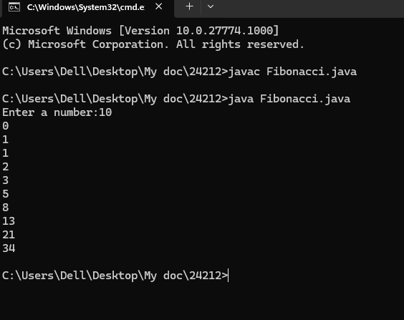
Error:
S.No | Error type | Reason for error
1 | Runtime error | error: file not found: Fibonacci.java  Usage: javac <options> <source files>  use --help for a list of possible options

- WRITE A JAVA PROGRAM TO CALCULATING TEMPERATURE IN CELSIUS
Program:
import java.util.*;
class temp
{
public static void main(String args[])
{
Scanner sc = new Scanner(System.in);
float c;
System.out.println("Enter Fahrenheit Temperature:");
float f = sc.nextFloat();
c = (f-32)*5/9;
System.out.println("celcius Temperature is :"+c);
}
}
Output:
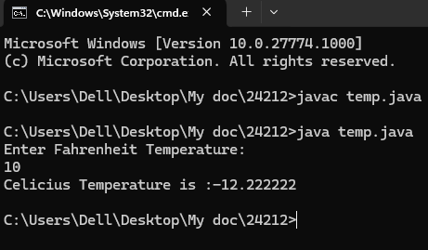
Error:
S.No | Error type | Reason for error
1. | Syntax | temp.java:7: error: ';' expected  Scanner sc = new Scanner(System.in)

- WRITE A JAVA PROGRAM TO FIND FACTORIAL OF A GIVEN NUMBER
Program:
import java.util.*;
class Fact
{
public static void main(String args[])
{
int number;
Scanner sc = new Scanner(System.in);
System.out.println("Enter a number:");
number = sc.nextInt();
System.out.println("Enter time:");
int answer = factorial(number);
System.out.println("factorial of"+ number + " is " + answer);

} static int factorial(int n){
if(n==1)
{
return 1;
}
return n * factorial(n-1);

}
}
Output:
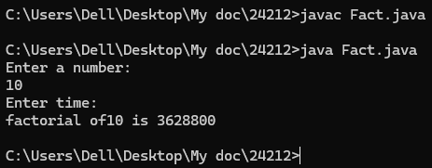

Error:
S.No | Error type | Reason for error | rectification
 | Logical error | Incorrect input | Correcting input
 | Runtime error | Incorrect path | Using correct path

- WRITE A JAVA PROGRAM TO CONVERTE CELSIUS TO FAHRENHEIT:
Program:
import java.util.*;
class heat
{
public static void main(String args[])
{
Scanner sc = new Scanner(System.in);
float f;
System.out.println("Enter Celsius Temperature:");
float c = sc.nextFloat();
f = (c*9/5)+32;
System.out.println("Fahrenheit Temperature is :"+f);
}
}
Output:
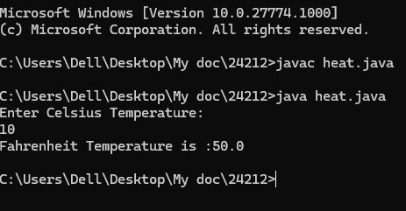
Error:

S.No | Error type | Reason for error | rectification
1. | Logical error | Incorrect input | Correcting input

- WRITE A JAVA PROGRAM TO CALCULATING AREA OF TRIANGLE USING HERONS’ FORMULA:
Program:
import java.util.*;
import java.lang.Math;

class Triangle{
public static void main(String[] args) {
double s, c, a, b, p;
Scanner sc = new Scanner(System.in);
System.out.println("Enter the value of a, b, and c:");
a = sc.nextDouble();
b = sc.nextDouble();
c = sc.nextDouble();
s = (a + b + c) / 2;
p = Math.sqrt(s * (s - a) * (s - b) * (s - c));
System.out.println("Area of triangle by Heron's formula is = " + p);
}
}

Output:
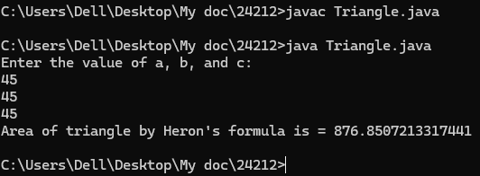
Error:

S.No | Error type | Reason for error | rectification
1. | Logical error | Incorrect input | Correcting input

WEEK -3
WRITE A JAVA PROGRAM TO CREATE A CLASS WITH CAR NAME:

PROGRAM:

class Main {
String car_color;
String car_brand;
String fuel_type;
int mileage;

// Constructor
public Main(String car_color, String car_brand, String fuel_type, int mileage) {
this.car_color = car_color;
this.car_brand = car_brand;
this.fuel_type = fuel_type;
this.mileage = mileage; // Fixed the spelling mistake here
}

// Getter methods
public String color() {
return car_color;
}

public String brand() {
return car_brand;
}

public String fuel() {
return fuel_type;
}

public int mile() {
return mileage;
}

// Main method
public static void main(String[] args) {
Main car1 = new Main("red", "Hyundai", "diesel", 19);
System.out.println("Car 1 - Color: " + car1.color() + ", Brand: " + car1.brand() +
", Fuel Type: " + car1.fuel() + ", Mileage: " + car1.mile());

Main car2 = new Main("blue", "Toyota", "petrol", 17);
System.out.println("Car 2 - Color: " + car2.color() + ", Brand: " + car2.brand() +
", Fuel Type: " + car2.fuel() + ", Mileage: " + car2.mile());

Main car3 = new Main("black", "Tata", "diesel", 19);
System.out.println("Car 3 - Color: " + car3.color() + ", Brand: " + car3.brand() +
", Fuel Type: " + car3.fuel() + ", Mileage: " + car3.mile());
}
}

Output:

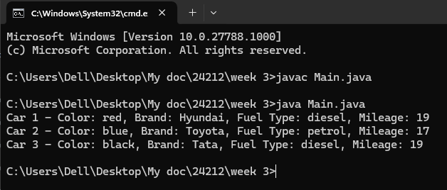
Error:

S.No | Error type | Reason for error
1. | Identifier error | Main.java:3: error: <identifier> expected  car_brand;  ^  1 error

WRITE A JAVA PROGRAM TO CREATE A CLASS BANK ACCOUNT WITH METHODS DEPOSIT AND WITHDRAWAL:

PROGRAM:
class Bank_Account {
private String accname;
private int acno;
private float balance;

// Constructor
public Bank_Account(String accname, int acno, float balance) {
this.accname = accname;
this.acno = acno;
this.balance = balance;
}

// Withdraw method
public void withdraw(int amount) {
if (amount <= balance) {
balance -= amount;
System.out.println("Withdrawal of " + amount + " successful. Remaining balance: " + balance);
} else {
System.out.println("Insufficient balance for " + accname);
}
}

// Deposit method
public void deposit(int amount) {
balance += amount;
System.out.println("Deposit of " + amount + " successful. Updated balance: " + balance);
}

// Method to display account details
public void displayDetails() {
System.out.println("Account Name: " + accname);
System.out.println("Account Number: " + acno);
System.out.println("Balance: " + balance);
}

public static void main(String[] args) {
Bank_Account s = new Bank_Account("Anil", 34571, 25000);
s.withdraw(20000);
s.deposit(2000);
s.displayDetails();

System.out.println(); // Just for better readability

Bank_Account s1 = new Bank_Account("Jeevan", 333226, 25000);
s1.withdraw(2500);
s1.deposit(250000);
s1.displayDetails();
}
}
OUTPUT:
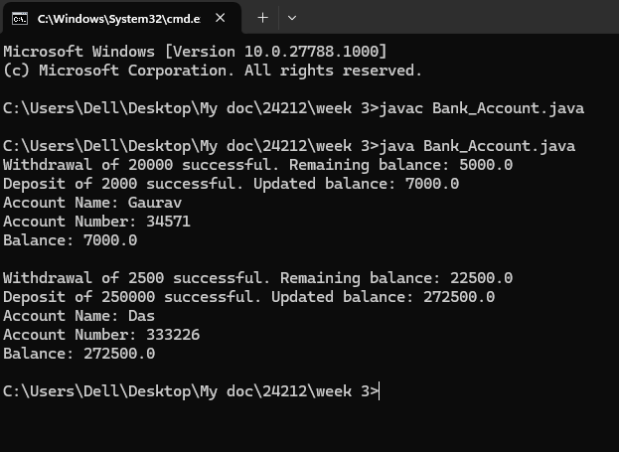
ERROR:
S.No | Error type | Reason for error
1. | Syntax | Bank_Account.java:7: error: ';' expected  Scanner sc = new Scanner(System.in)

WEEK-4
TO CREATE A JAVA PROGRAM WITH CLASS NAMED “MYCLASS” WITH A STATIC VARIABLE COUNT OF “INT” TYPE ,INSIZED TO “ZERO” AND A CONSTANT VARIABLE “PI” OF TYPE “DOUBLE” INITIALIZED TO 3.1415 AS ATTRIBUTES OF THAT CLASS . DEFINE A CONTRUCTOR FOR “MYCLASS” IS CREATED FINALLY PRINT THE FINAL VALUES “COUNT” AND “PI” VARIABLES.
PROGRAM:
public class MyClass {
public static int count = 0;
public static final double PI = 3.14;

public MyClass() {
count++;
}

public static void main(String[] args) {
MyClass obj1 = new MyClass();
MyClass obj2 = new MyClass();
MyClass obj3 = new MyClass();

System.out.println("Count: " + count);
System.out.println("PI: " + PI);
}
}
OUTPUT:
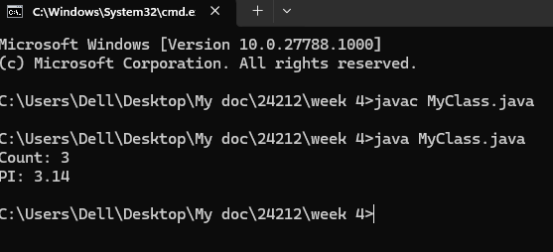
Error:
S.No | Error type | Reason for error
1. | Syntax | MyClass.java:7: error: ';' expected  Scanner sc = new Scanner(System.in)

CLASS DIAGRAM
MyClass
- count: int (static)
- pi: double (static final)

+ MyClass()
+ main(String[] args): void

TO CREATE A JAVA PROGRAM WITH CLASS NAMED” BOOK”. THE CLASS SHOULD CONTAIN VARIOUS ATTRIBUTES SUCH AS “TITLE OF THE BOOK”, “AUTHOR”, YEAR OF PUBLICATIONS”, IT SHOULD ALSO CONTAIN A CONSTRUCTOR WITH PARAMETER WHICH INITIALIZES “TITLE OF THE BOOK”, “AUTHOR”, “YEAR OF PUBLICATION”. CREATE A METHOD WHICH DISPLAYS THE DETAILS OF THE BOOK. TITLE OF THE BOOK (), AUTHOR (), YEAR OF PUBLICATION ().DISPLAY THE DETAILS OF TWO BOOK, BY CREATING 2 OBJECTS.
PROGRAM:
class book{
public String title;
public String author;
public int year_of_publication;

public book(String title, String author, int year_of_publication){
this.title = title;
this.author = author;
this.year_of_publication = year_of_publication;
}

public void printbookDetails(String title, String author, int year_of_publication){
System.out.println("Title of book: " + title);
System.out.println("Author for this book: " + author);
System.out.println("Year of publication: " + year_of_publication);
}

public static void main(String[] args){
book book = new book("Harry Potter", "J.K.Rowling", 2001);
book.printbookDetails(book.title, book.author, book.year_of_publication);
}
}

OUTPUT:
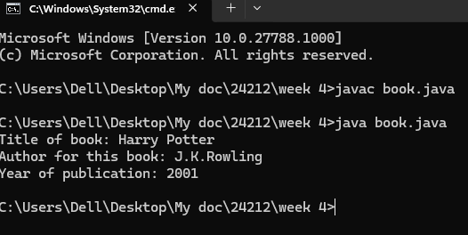
Error:
S.No | Error type | Reason for error
1 | Runtime error | error: file not found: book.java  Usage: javac <options> <source files>  use --help for a list of possible options

CLASS DIAGRAM
Book
- title: String
- author: String
- year: int
Book(String, String, int)
+ displayDetails(): void

